Normalization 1:

UNF

TRANSPORT_VEHICLE (vehicle_id, vehicle_registrationnumber, vehicle_make, vehicle_model, vehicle_year, vehicle_odometer, vehicle_passengers, features)

FDs:

* **vehicle_id ->** vehicle_registrationnumber, vehicle_make, vehicle_model, vehicle_year, vehicle_odometer, vehicle_passengers, features
* vehicle_registrationnumber **->** vehicle_make, vehicle_model, vehicle_year, vehicle_odometer, vehicle_passengers, features
* **vehicle_model, vehicle_year->vehicle_make**
* **vehicle_make, vehicle_model, vehicle_year->features**

1NF

TRANSPORT_VEHICLE (vehicle_id, vehicle_registrationnumber, vehicle_make, vehicle_model, vehicle_year, vehicle_odometer, vehicle_passengers)

CKs:

* vehicle_id
* vehicle_registrationnumber

Partial dependencies:

**vehicle_model, vehicle_year->vehicle_make**

**vehicle_make, vehicle_model, vehicle_year->features**

2NF

TRANSPORT_VEHICLE (vehicle_id, vehicle_registrationnumber, vehicle_model, vehicle_year, vehicle_odometer, vehicle_passengers)

FEATURES (vehicle_make, vehicle_model, vehicle_year,features)

Transitive dependencies:

No transitive dependencies in TRANSPORT_VEHICLE and FEATURES table

3NF

TRANSPORT_VEHICLE (vehicle_id, vehicle_registrationnumber, vehicle_model, vehicle_year, vehicle_odometer, vehicle_passengers)

Full Dependencies:

vehicle_id --> vehicle_registrationnumber, vehicle_model, vehicle_year, vehicle_odometer, vehicle_passengers

FEATURES (vehicle_make, vehicle_model, vehicle_year,features)

Full Dependencies:

**vehicle_make, vehicle_model, vehicle_year->features**

Normalization 2:

UNF

TRIP(trip_id, assigned_vehicle_id, assigned_rego, assigned_driver_ID, assigned_driver_name, booked_official_ID, booked_official_name, no_of_vehicle_passengers, pick_up_location_ID, pick_up_location_name, pick_up_location_type, pick_up_location_address, intended_pick_up_time, actual_pick_up_time, drop_off_location_ID, drop_off_location_name, drop_off_location_type, drop_off_location_address, intended_drop_off_time, actual_drop_off_time)

Fds:

assigned_vehicle_id --> assigned_rego*

assigned_rego --> assigned_vehicle_id*

assigned_driver_ID --> assigned_driver_name

booked_official_ID --> booked_official_name

pick_up_location_ID --> pick_up_location_name, pick_up_location_type, pick_up_location_address

drop_off_location_ID --> drop_off_location_name, drop_off_location_type, drop_off_location_address

1NF

TRIP(trip_id, assigned_vehicle_id, assigned_rego, assigned_driver_ID, assigned_driver_name, booked_official_ID, booked_official_name, no_of_vehicle_passengers, pick_up_location_ID, pick_up_location_name, pick_up_location_type, pick_up_location_address, intended_pick_up_time, actual_pick_up_time, drop_off_location_ID, drop_off_location_name, drop_off_location_type, drop_off_location_address, intended_drop_off_time, actual_drop_off_time)

CKs:

* trip_id

Partial dependencies:

No partial dependencies present

2NF

TRIP(trip_id, assigned_vehicle_id, assigned_rego, assigned_driver_ID, assigned_driver_name, booked_official_ID, booked_official_name, no_of_vehicle_passengers, pick_up_location_ID, pick_up_location_name, pick_up_location_type, pick_up_location_address, intended_pick_up_time, actual_pick_up_time, drop_off_location_ID, drop_off_location_name, drop_off_location_type, drop_off_location_address, intended_drop_off_time, actual_drop_off_time)

Transitive dependencies:

assigned_vehicle_id --> assigned_rego*

assigned_rego --> assigned_vehicle_id*

assigned_driver_ID --> assigned_driver_name

booked_official_ID --> booked_official_name

pick_up_location_ID --> pick_up_location_name, pick_up_location_type, pick_up_location_address

drop_off_location_ID --> drop_off_location_name, drop_off_location_type, drop_off_location_address

3NF

TRIP(trip_id, assigned_vehicle_id, assigned_driver_ID, booked_official_ID, no_of_vehicle_passengers, pick_up_location_ID, intended_pick_up_time, actual_pick_up_time, drop_off_location_ID, intended_drop_off_time, actual_drop_off_time)

DRIVER(assigned_driver_ID, assigned_driver_name)

OFFICIAL(booked_official_ID, booked_official_name)

PICK_UP_LOCATION(pick_up_location_ID, pick_up_location_name, pick_up_location_type, pick_up_location_address)

DROP_OFF_LOCATION(drop_off_location_ID, drop_off_location_name, drop_off_location_type, drop_off_location_address)

Full Dependencies:

trip_id --> assigned_vehicle_id, assigned_driver_ID, booked_official_ID, no_of_vehicle_passengers, pick_up_location_ID, intended_pick_up_time, actual_pick_up_time, drop_off_location_ID, intended_drop_off_time, actual_drop_off_time

assigned_driver_ID --> assigned_driver_name

booked_official_ID --> booked_official_name

pick_up_location_ID --> pick_up_location_name, pick_up_location_type, pick_up_location_address

drop_off_location_ID --> drop_off_location_name, drop_off_location_type, drop_off_location_address

Attribute Synthesis:

Combined PICK_UP_LOCATION and DROP_OFF_LOCATION into LOCATION(location_ID, location_name, location_type, location_address)

FINAL 3NF Relations:

TRIP(trip_id, assigned_vehicle_id, assigned_driver_ID, booked_official_ID, no_of_vehicle_passengers, pick_up_location_ID, intended_pick_up_time, actual_pick_up_time, drop_off_location_ID, intended_drop_off_time, actual_drop_off_time)

DRIVER(assigned_driver_ID, assigned_driver_name)

OFFICIAL(booked_official_ID, booked_official_name)

LOCATION(location_ID, location_name, location_type, location_address)

Joining 3NF from Normalization 1 and Normalization 2:

* TRANSPORT_VEHICLE (vehicle_id, vehicle_registrationnumber, vehicle_model, vehicle_year, vehicle_odometer, vehicle_passengers)
* FEATURES (vehicle_model, vehicle_year, vehicle_make, features)
* TRIP(trip_id, assigned_vehicle_id, assigned_driver_ID, booked_official_ID, no_of_vehicle_passengers, pick_up_location_ID, intended_pick_up_time, actual_pick_up_time, drop_off_location_ID, intended_drop_off_time, actual_drop_off_time)
* DRIVER(assigned_driver_ID, assigned_driver_name)
* OFFICIAL(booked_official_ID, booked_official_name)
* LOCATION(location_ID, location_name, location_type, location_address)

ASSUMPTIONS:

* One vehicle can have zero or many features.
* One vehicle can be booked for either no or many trips.
* Each official must have gone for one or many trips.
* There is the possibility that some locations never got to be the drop off locations and some locations never got to be pickup locations and it is also possible that some locations got to be drop off locations multiple times and some locations got to be pick up locations multiple times.
* One assigned vehicle for the trip can have only one registration number so there is no need of a separate table.

**Logical Design:**

Draft1:

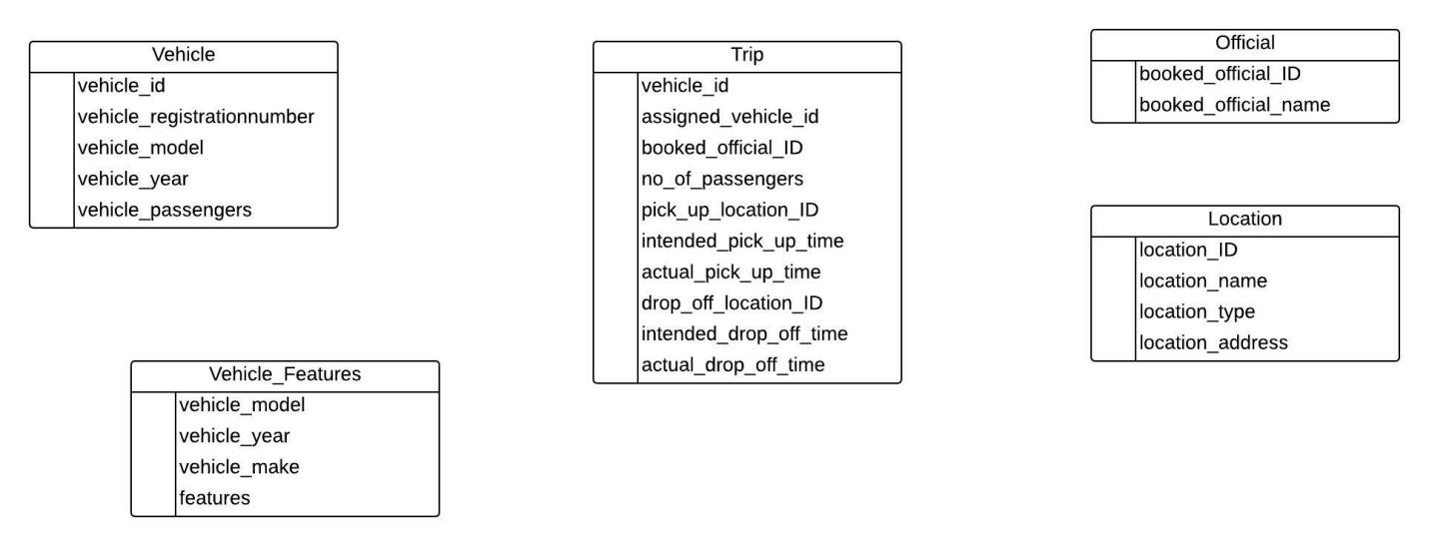

Draft2: 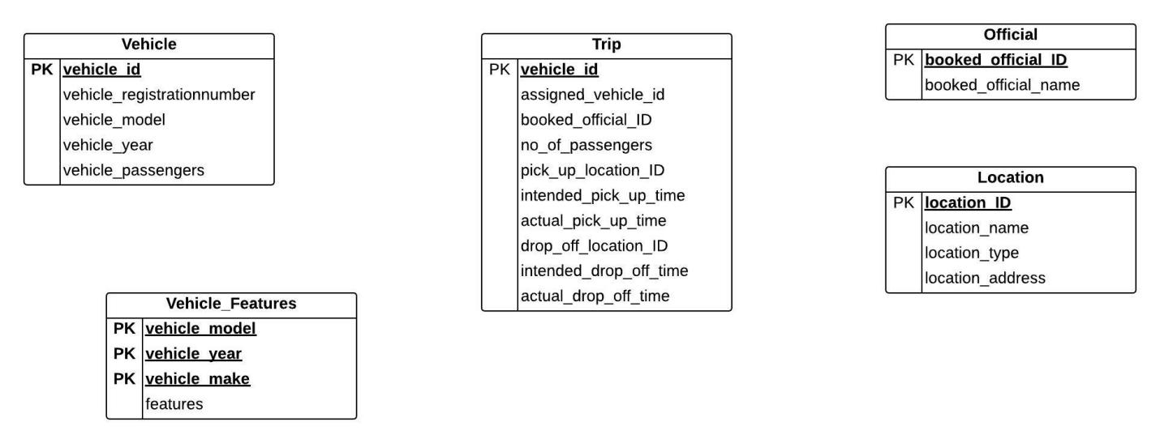

Draft3:

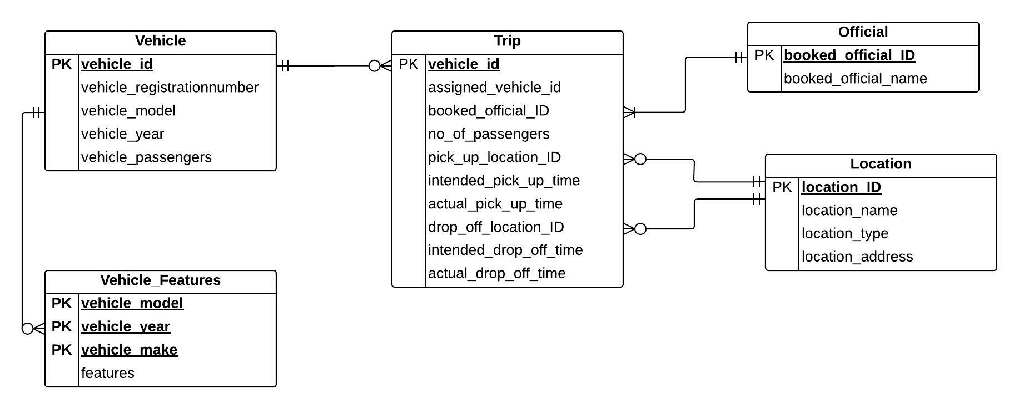

Draft4 (final):

